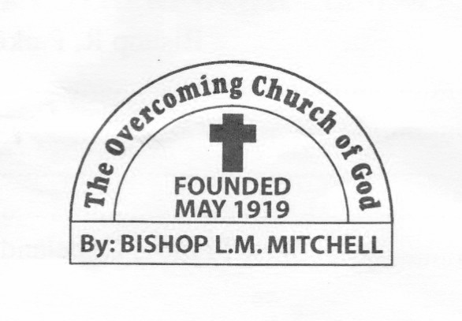
Saint Stephen - Mother Church
279 Hemphill School Road
Atlanta, Georgia 30331
Telephone (404) 696-3831
Date:

To: Presiding Bishop Dr. Nicky P. Starling

From: District Bishop, (Name)

(1st) Trinal Meetings held: October 2015 - January 2016
Overcoming Church of God of America, inc.

“Trinal Meeting Reports”

Greetings in the name of our Lord and Savior Jesus Christ; it gives me great pleasure to make this 1st Trinal Report as serving in the position of District Bishop/Presiding Elder. Attached are my 1st Trinal Meeting Reports for the following churches:

(Please list Church names, city/state and dates of visit and miles traveled and lodging if any)

(Example)
St. Stephen, Atlanta, GA - Sunday, November 15, 2015 - 30 miles round trip - Lodging (none)

If you have any questions or concerns after reviewing the attached reports, you may contact me at (XXX) XXX - XXXX.

Yours in the Master’s Service

(Name), District Bishop/Presiding Elder

1st Trinal Meeting Report

(Name), District Bishop/Presiding Elder

(Church Name)

(Pastor Name)

(Chairman of the Deacon Board Name)

Date(s) of Meeting(s):

My Findings:

Church Concerns:
(Pastor, Deacons, Ministers, Mothers, Church members)

My Suggestions:

Church Accomplishments:

Trinal Business Conducted:
(According to “Regulations for Holding Trinal Meetings)

Other Comments:

